Datastage

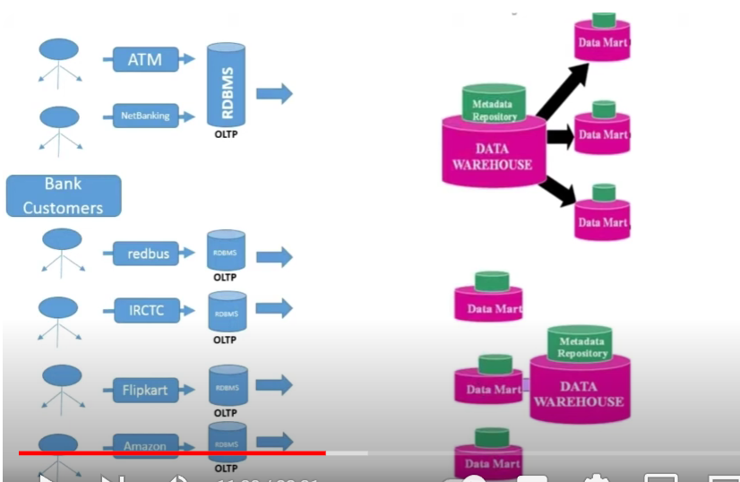

Datawarehouse is nothing but storage for long run (years) and it’s a storage of all categories

Where as Datamart is nothing but category storage

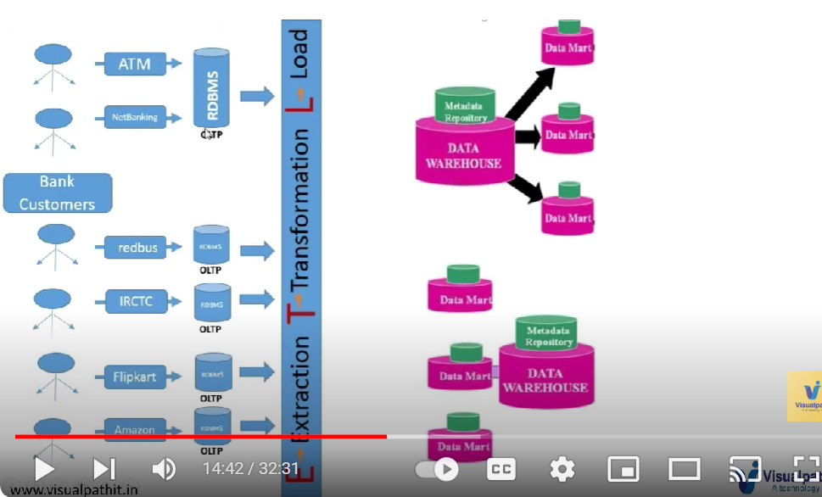

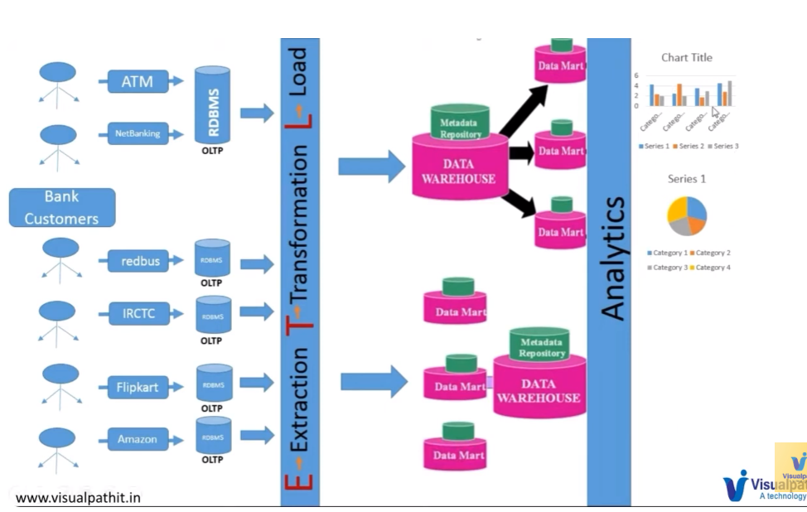

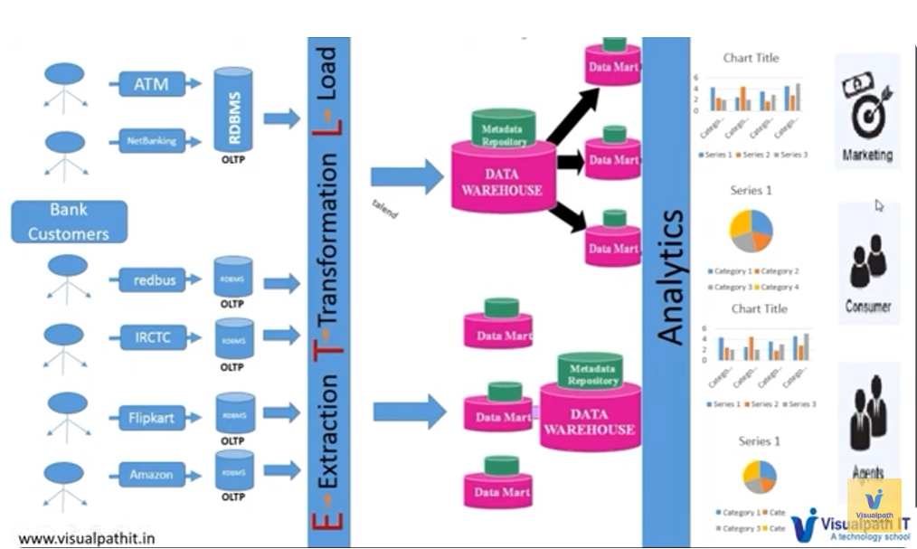

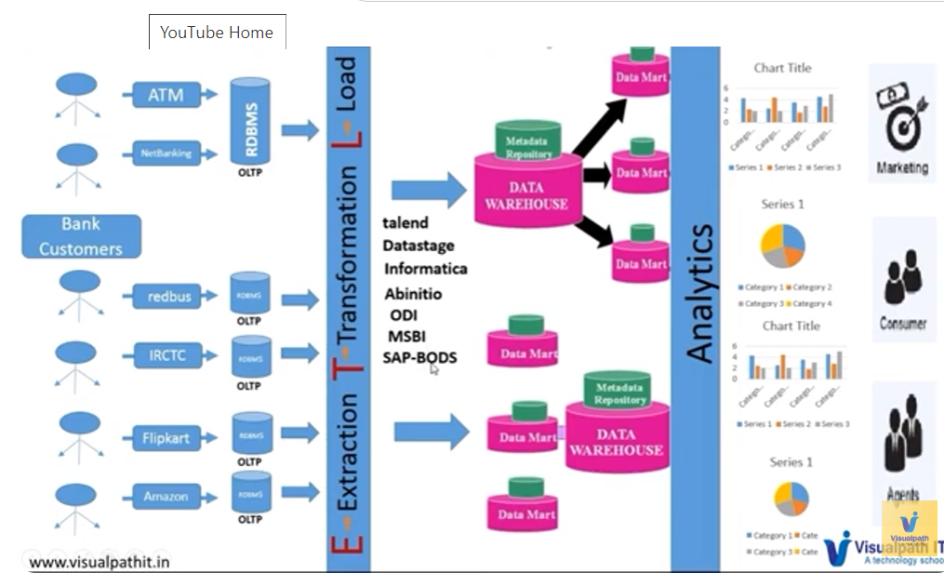

Datawarehouse : is a storage in a systematic manner

Generally, all the grains, food, storage, just food items, everything or else the refrigerator, a small kind of a good one.

So if we arrange all the items in a systematic manner, if you arrange all the items in a systematic manner, OK, all the groceries, whatever that we are having, if arrange them in a systematic manner so that we can remove that in a systematic manner.OK, so data warehouse is nothing but the place.

The place where we store the data where we store the data in a some specified structural manner in some specified structural manner, so that whenever you want to suppose I want to, I want to retrieve the data somewhere around three months back.

ETL tools are the tools which are easy for conversions

Comparatively all the tools of ETL there are many options in datastage

Its high in the market bcz of parallel partition and its cons are the charges are very high (ibm charges)

* The main moto of datastage is ETL(Extraction , transaction , loading)
* There are many operations which we can perform in Datastage but each opearation has different clients and servers
* IBM IIS is a one of a tool where we install a software

We need to have a server where we install its OS , might be windows or on unix but mostly in projects they install in unix server

* For interacting with a tool we installed in a server which is client
* 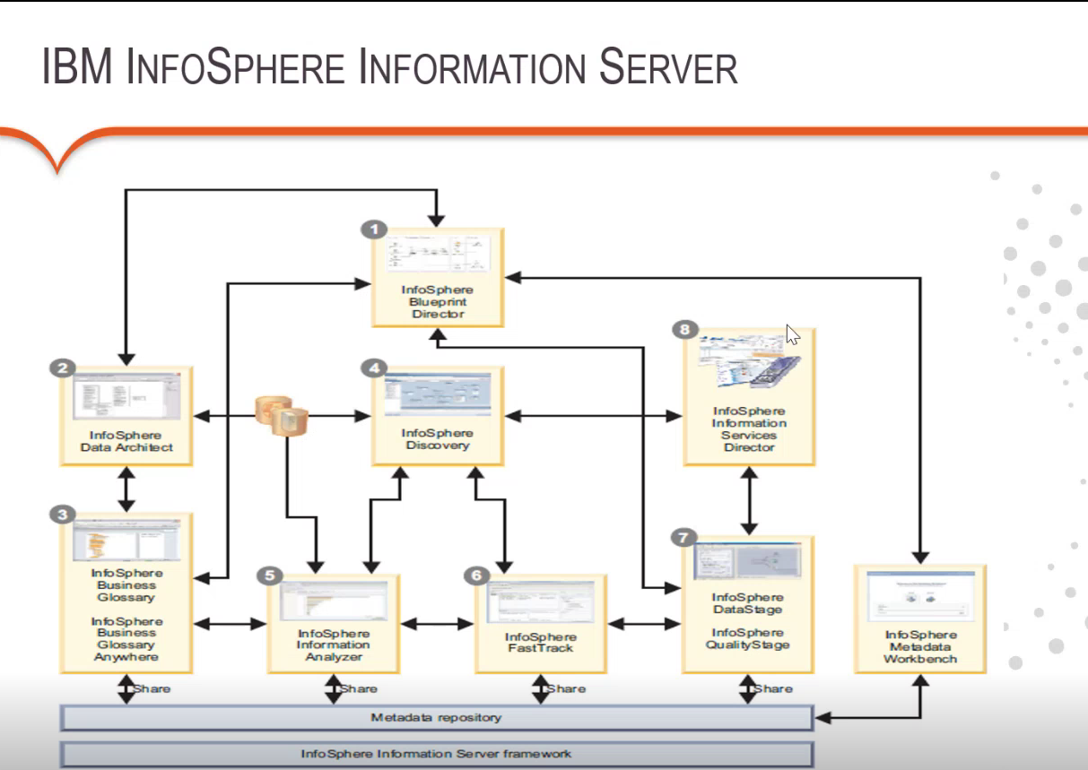
* The above all are clients
* We will having our clients installed in our machines
* Ibm datastage and quality stage are clients
* We have director client for debugging process .
* If we want to do profiling activity (to keep data in a structured way ) we have ibm infosphere information server analyzer
* If you want to do anykind of documentation we have fast track client .
* For metadata management we are having work data ,infosphere metadata workbench
* **But as a datastage developer we are only having two clients datastage designer & quality stage .**
* In Quality stage we can perform quality rules , we can compare the data

**Quality rules example.**

If we're having a pan card, guys and the pan card should be having when specified structure data that is nothing but plus filters.

That should be characters under next 4 next four values should be number, our next value should be alphabet, so totally 10 characters will be having five are alphabets, 4 our numbers and last one is alphabet.

So this is the way we will be having Suppose if you are not having in that expected format, we can create a rule over there in the by using this qualities quality stage as whatever that you're having and we can apply if the data is not in that specified format structure, we can drop the data

and we can.

* **For Performing an ETL CODE we call it as job where as in c language we call it as c progragramming**
* **For developing jobs we use GUI tool and its components called Stages**
* **Each stage has their own activity**
* **There are few stages which helps us to extract data from database from different source systems.**
* **Suppose for example, I'm having a table in my SQL Server.I can extract the data from the SQL Server.I can extract the data from that SQL Server by using one of the stage called connector stage**
* **OK, similarly if you want to extract the data from a different server, call a different database called DB2. Will have stage called DB2 Connector stage.**
* **Suppose if I'm extracting the data from any file system from the Unix, I mean from the Unix server we are having it, we can extract it by using the sequential files and the flat files stage.**
* **If you are extracting the data from the Hadoop system, you can have a stage called HDFS.**
* **For different extractions will be having different stages and it has extraction capacity as well as loading capacity.**
* **The stages which are used to extract and load are called passive stages**
* **For transformations will have active stages**

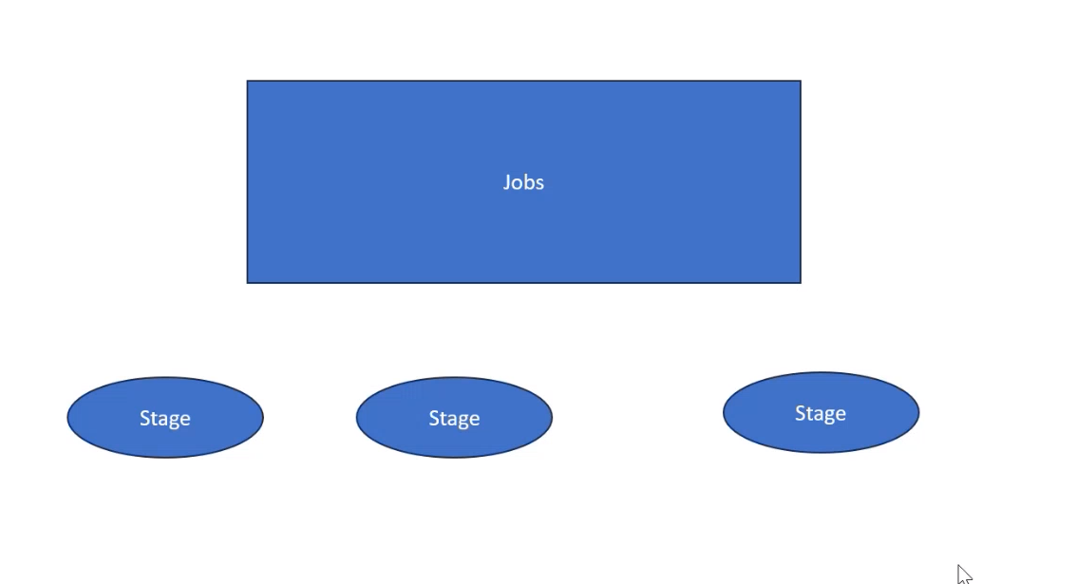

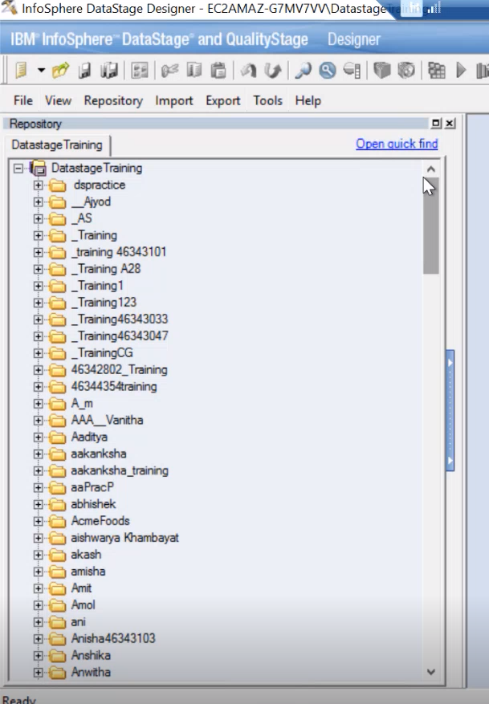 **This window is called repository window in infosphere datastage designer where we can store everything in this section**

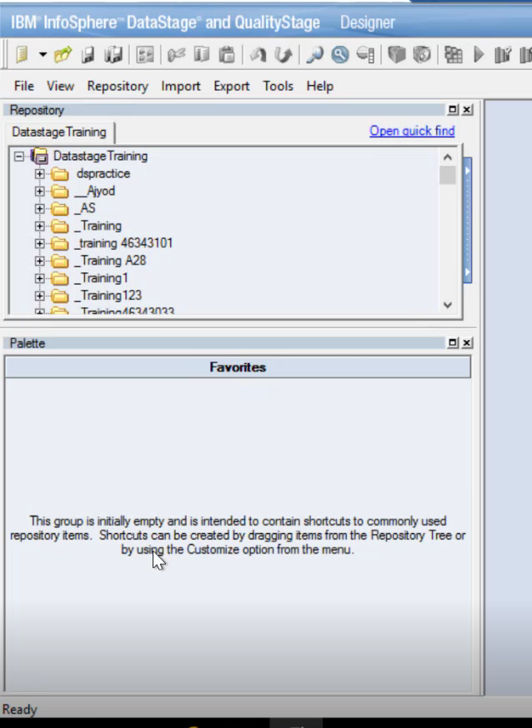

**We are having another window called palette where we can see all the stages over here**

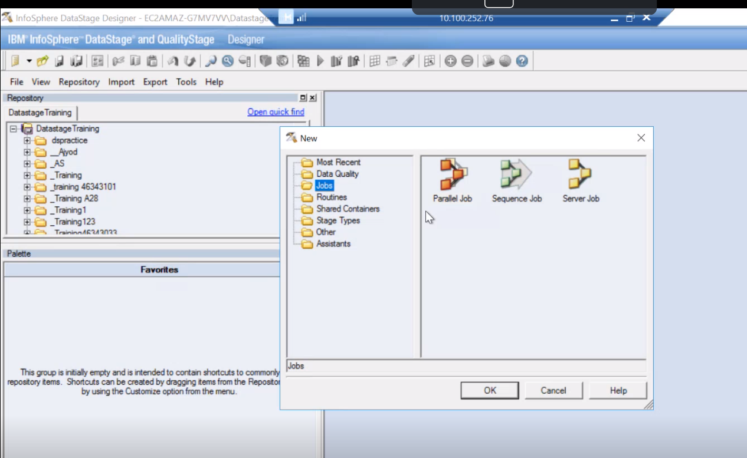 **if you want to create new job file -> new -> jobs you will get three types of jobs parallel job , sequence, job , server job**

1. Now server jobs are rarely used mostly parallel jobs and sequence jobs are used

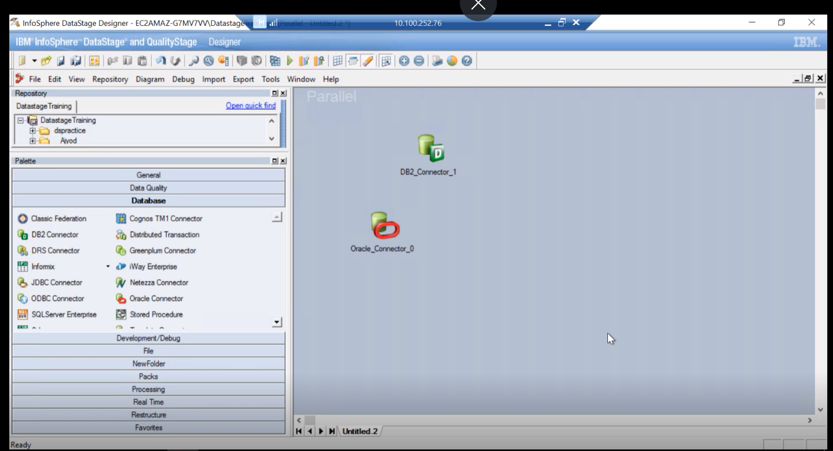

**In the above pallete we are having stages in different sections for example we have oracle connector in database section which is used to connect oracle database and fetch the data into datastage tool**

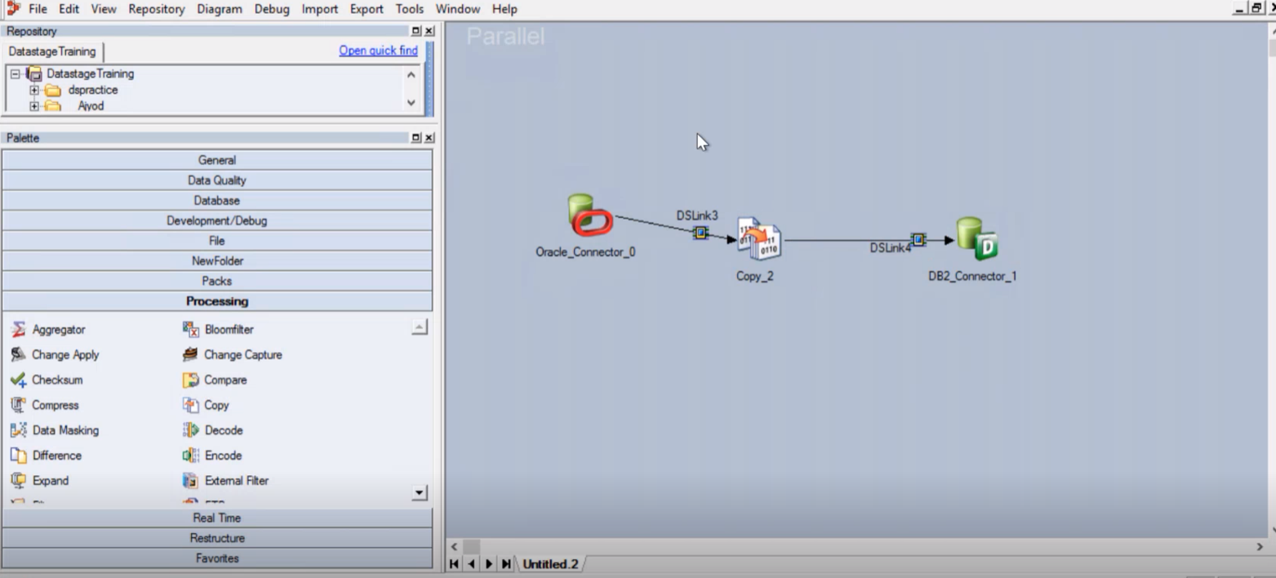

**Its nothing but we should select right properties to perform operations**

**Each stage has unique properties**

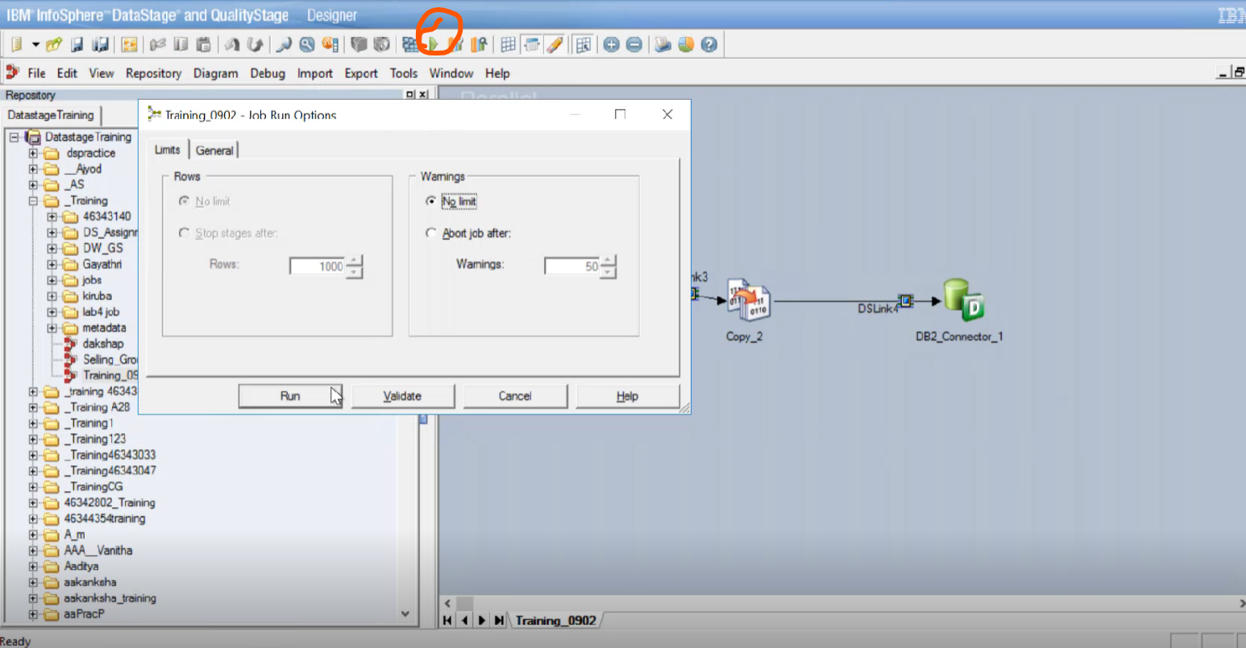

* **This is the place where we run the job**
* **In Designer client we can create jobs compile the jobs but if we want check the status of the jobs we need to check the logs whether they are successful or failed**
* **In Director client we can monitor jobs ,and we can view the jobs just as debugging the jobs**

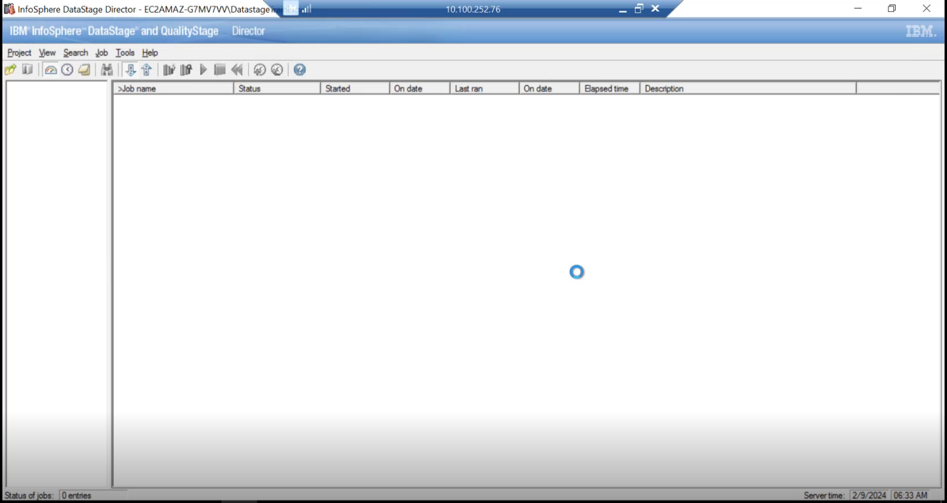

* This is the director client
* For connecting to the director client we can directly connect through designer client
* 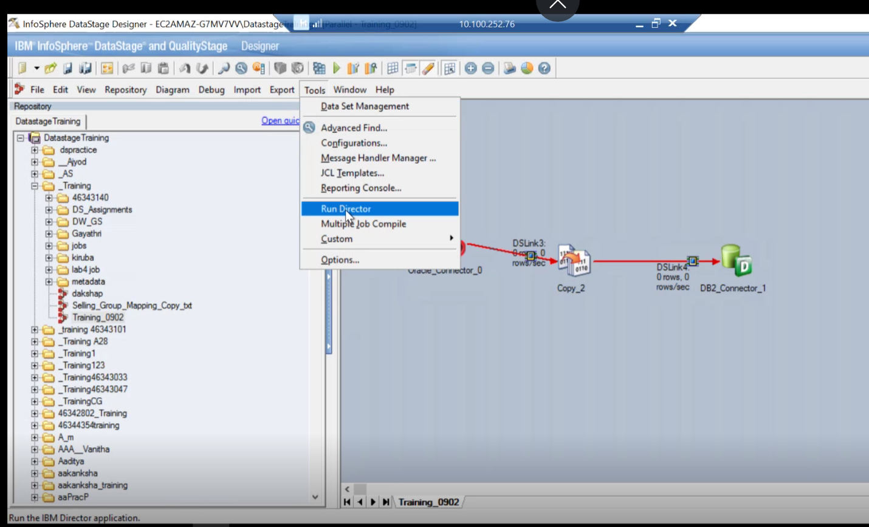
* Click tools-> run director

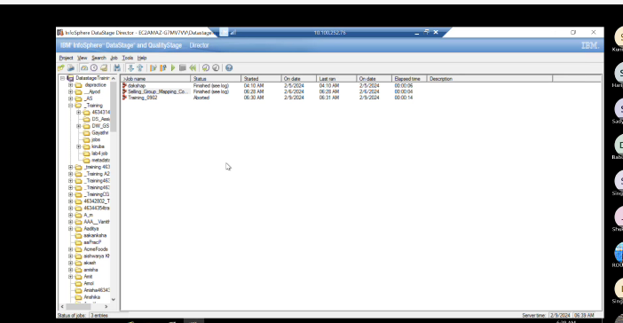

gTo view the log right click on job name and click on logs

* In logs you can also view the warnings
* 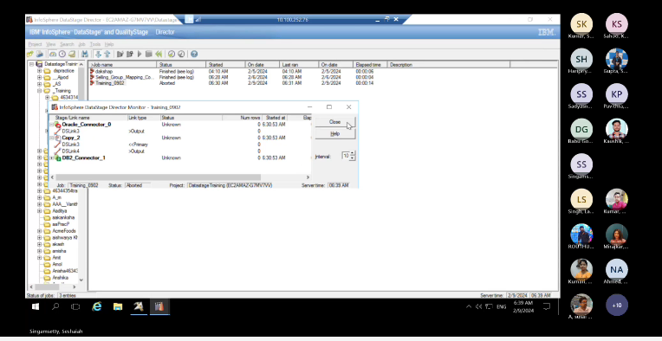
* You can also monitor the logs by clicking on tools -> monitor
* In director client you don’t have an option called compile and designer client you have option called compile or run
* Parallel jobs are jobs we can execute jobs one at a time
* Sequence jobs are the jobs which can execute or compile multiple parallel jobs sequentiall
* 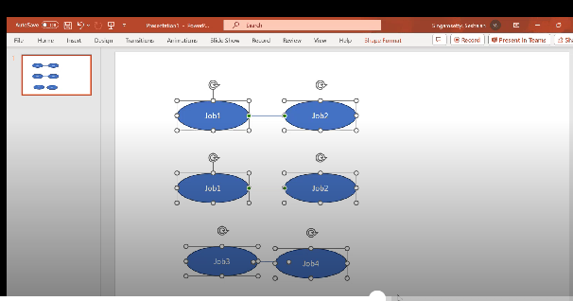
* We can group the sequence jobs & divide the sequence jobs according to the requirement
* For example above shown job1 and job 2 are relatable so we can create one sequence job to run
* above shown job3 and job4 are relatable so we can create one sequence job to run
* above shown job5 and job6 are relatable so we can create one sequence job to run
* if job 1 , job 2 , ……job 6 are relatable we can create one sequence job to group together

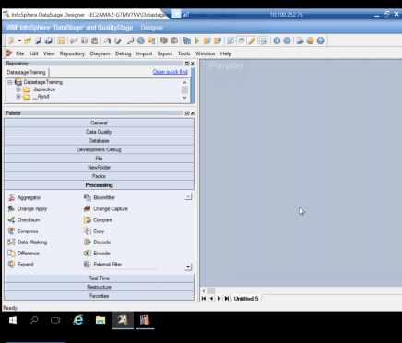

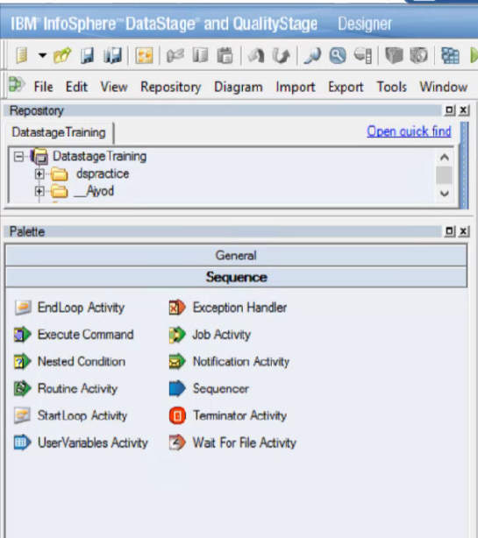

Sequence job stages

Parallel jobs stages

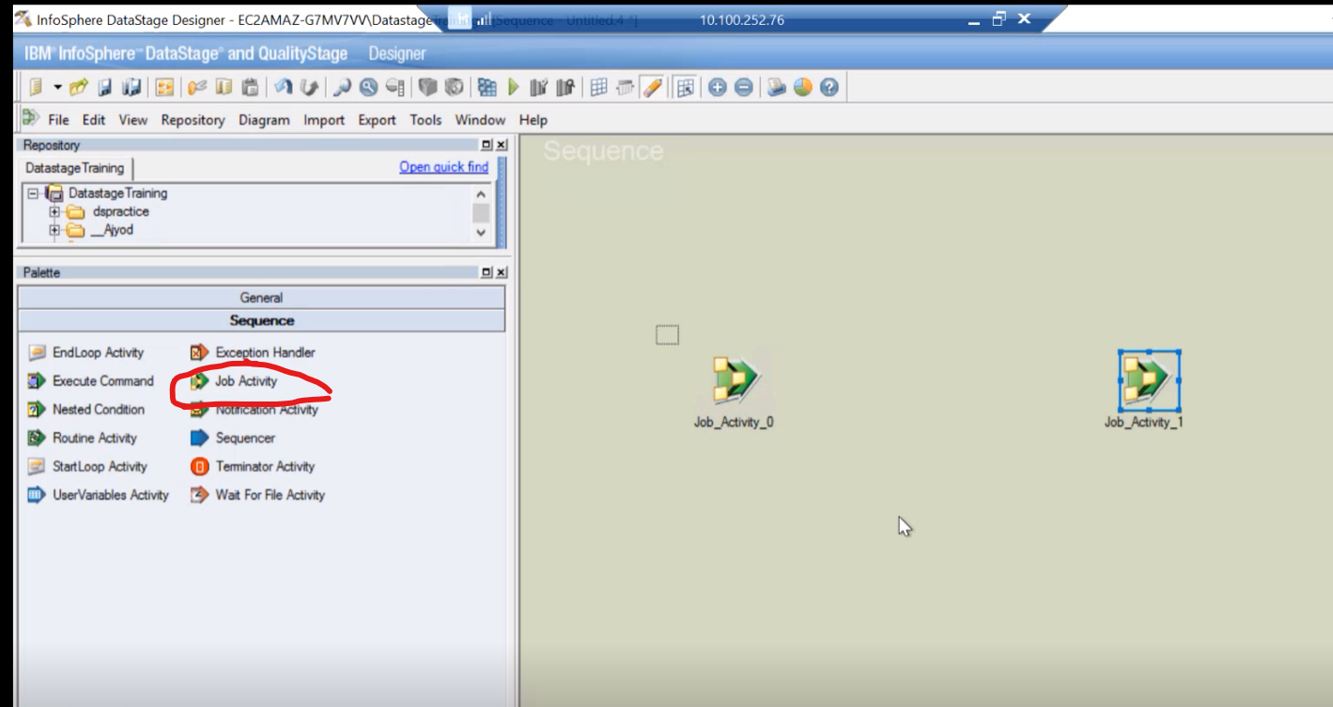

By clicking on job activity stage we can select parallel jobs to link or group it

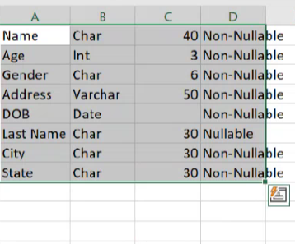

This is metadata that means giving some structure to a data

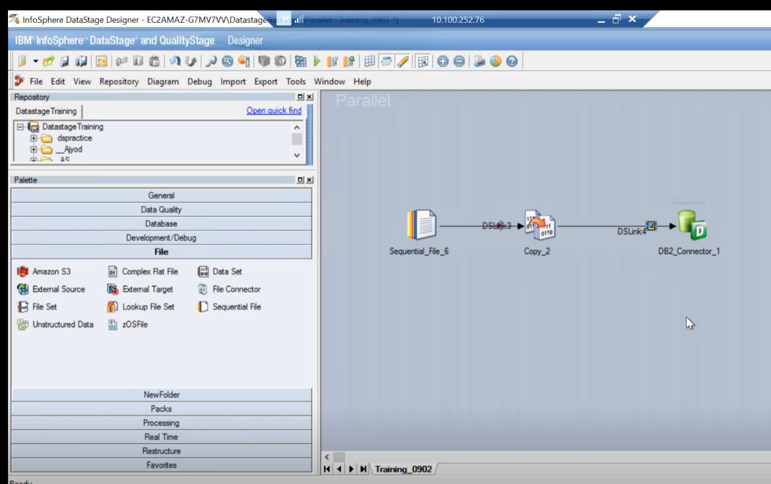

Sequential file is used to read the the files and write the files in another format like csv format , .txt etc

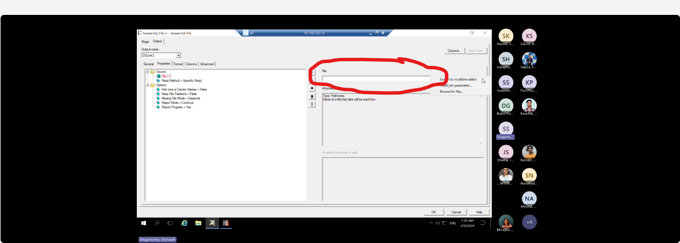

To fetch the files browse files from there

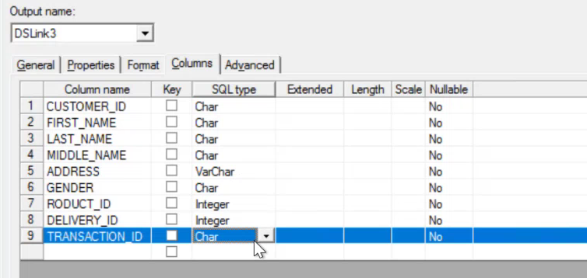sss

This is the meta data of file

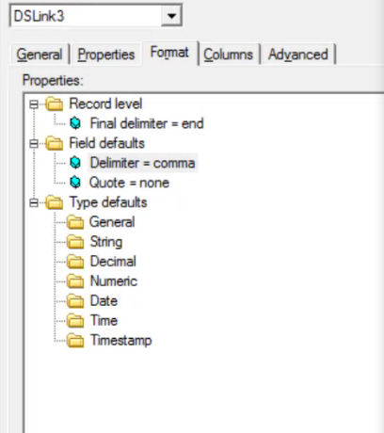

If you give correct data then only

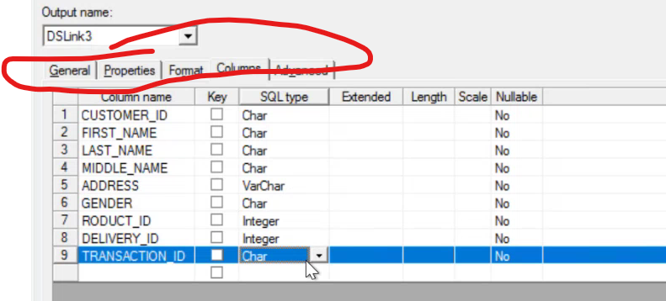

If you give correct data in format then only You will fetch the data into database if not you will get error



Copy file format allows you to select which ever data you want

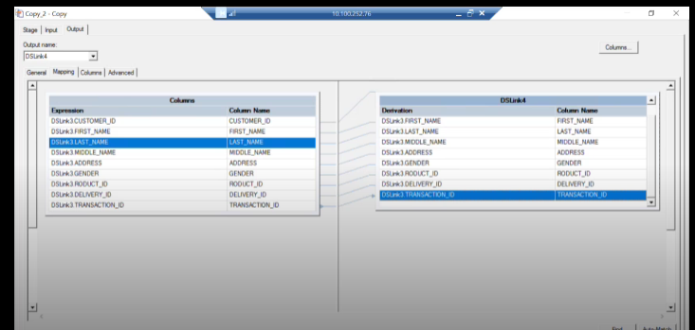

This is how you link in copy section

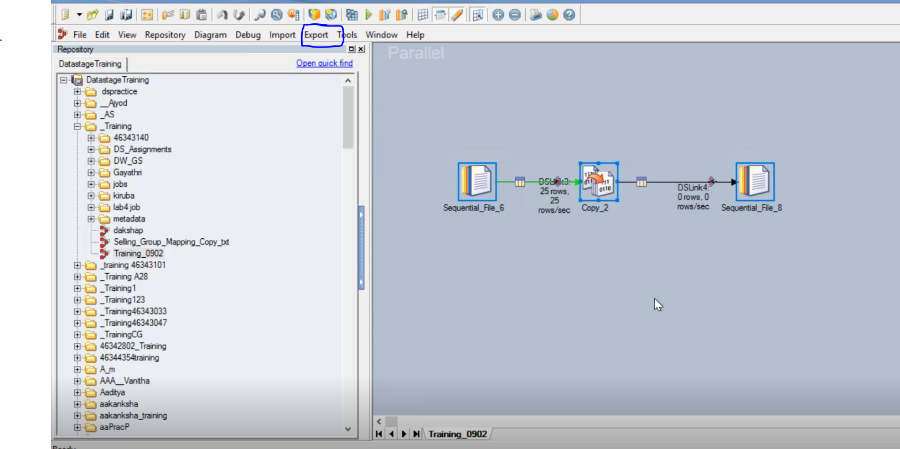

If you want back up for your job you can export it to your local machine

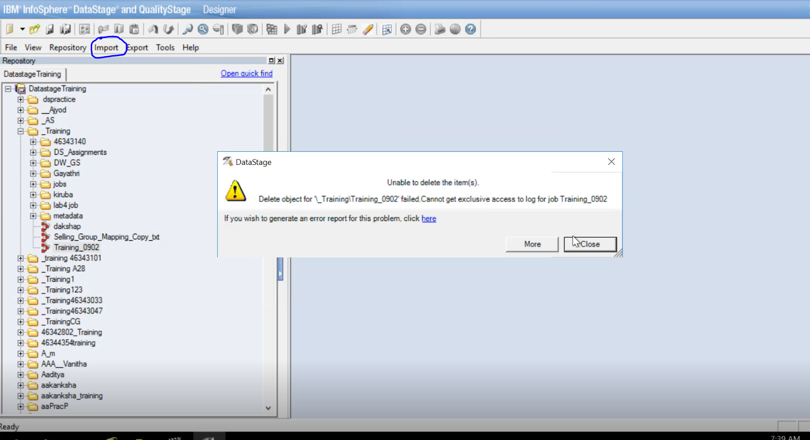

**To import from your local machine click on import**

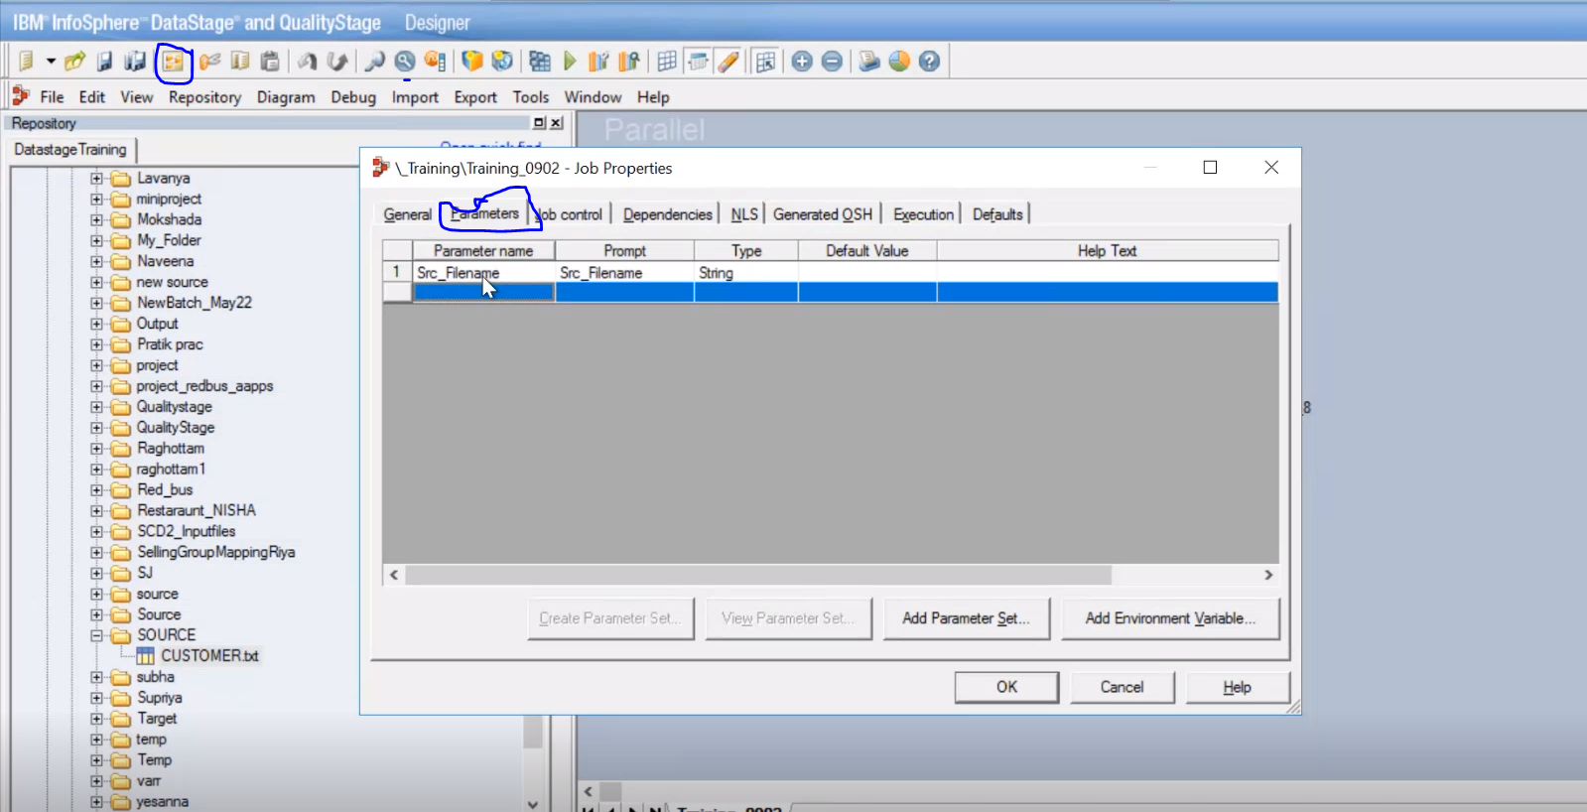

**To create parameters**

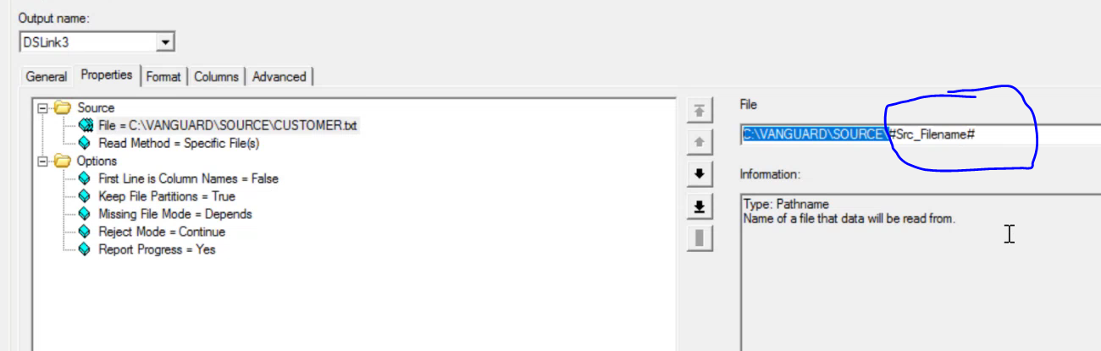

**Only the circle part is parameterised as its dynamic**

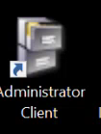

**Here administrator can create a new user or delete an existin user according to the requirement**

Sequence jobs

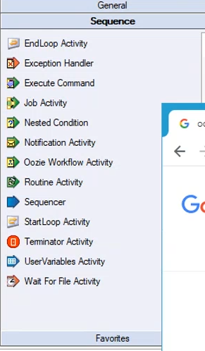

**Development /Debug**

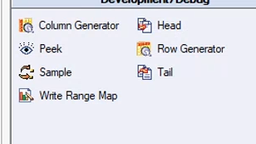

Column generator is for generating dummy columns

Peek is for viewing the data

Row generator is for generating the rows

**File section**

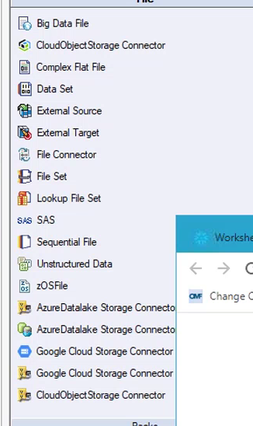

Sequential file and data set

Dataset: It stores data in the ASCII format so it takes less time to read data for datastage. IT can accommodate large amount of data. Sequential file stage: It contains data in the readable format, it can accommodate only 2GB data.

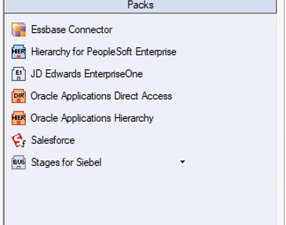

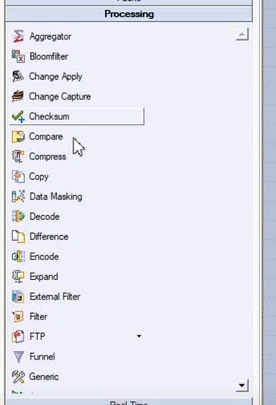

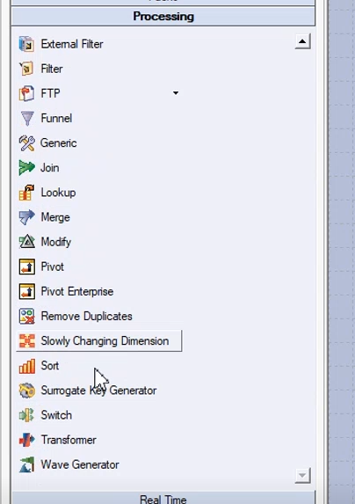

**Partitioning Techniques**

**1. Horizontal Partitioning/Sharding**

In this technique, the dataset is divided based on rows or records. Each partition contains a subset of rows, and the partitions are typically distributed across multiple servers or storage devices. Horizontal partitioning is often used in distributed databases or systems to improve parallelism and enable load balancing.

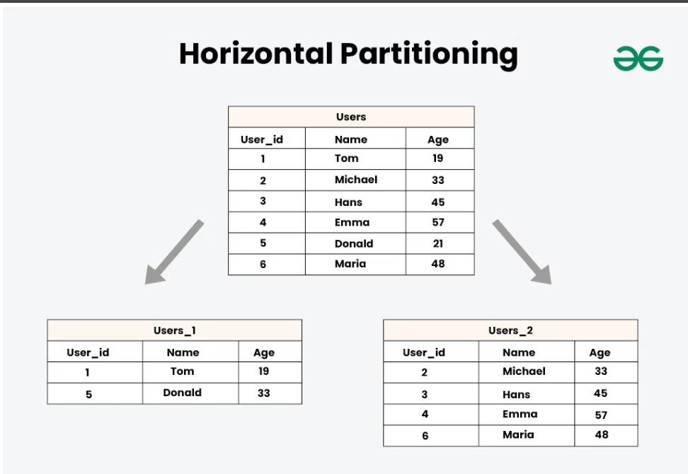

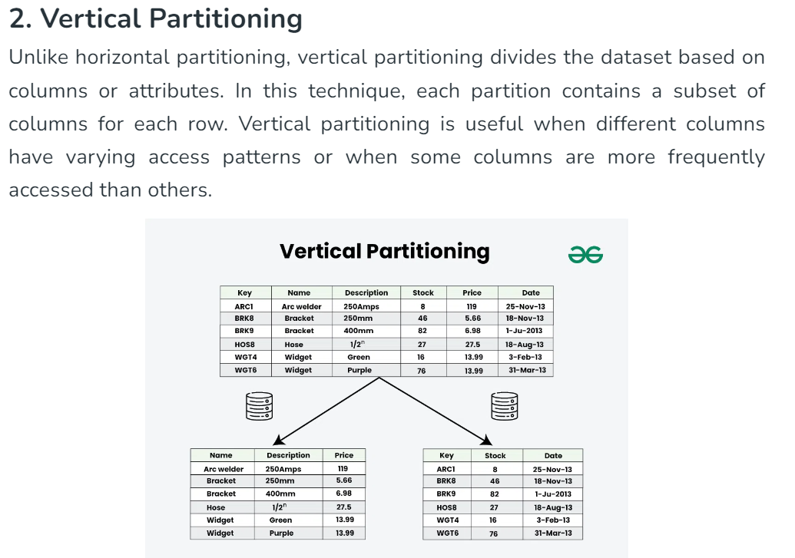

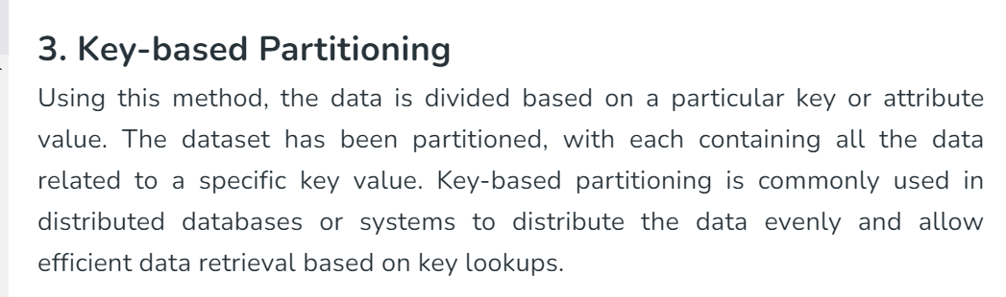

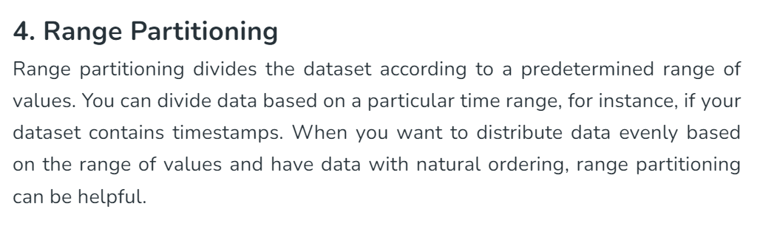

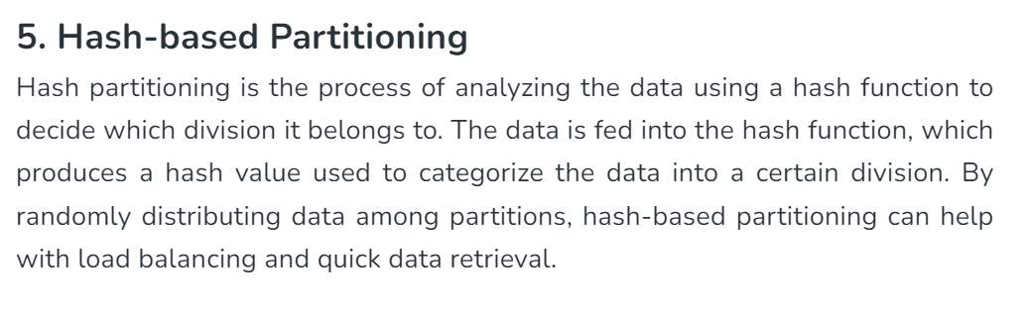

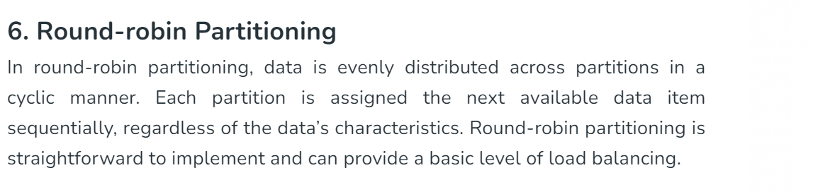

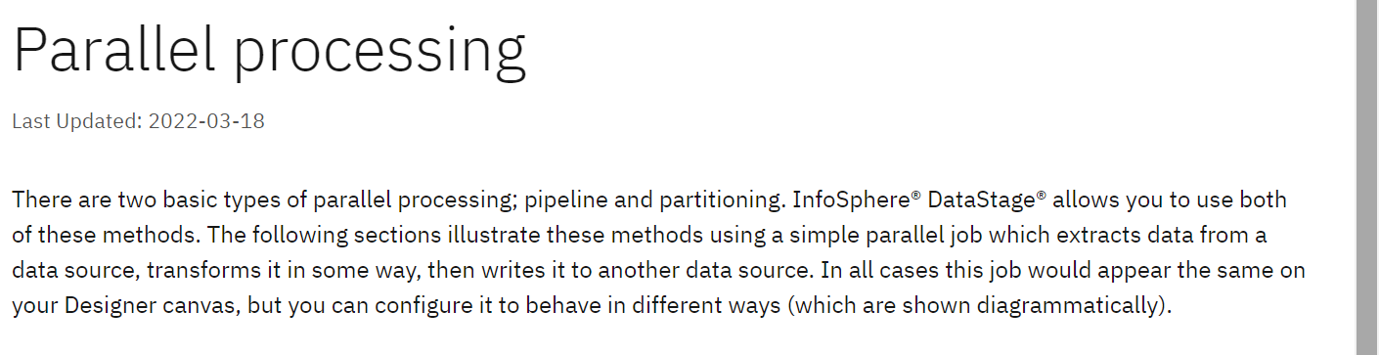

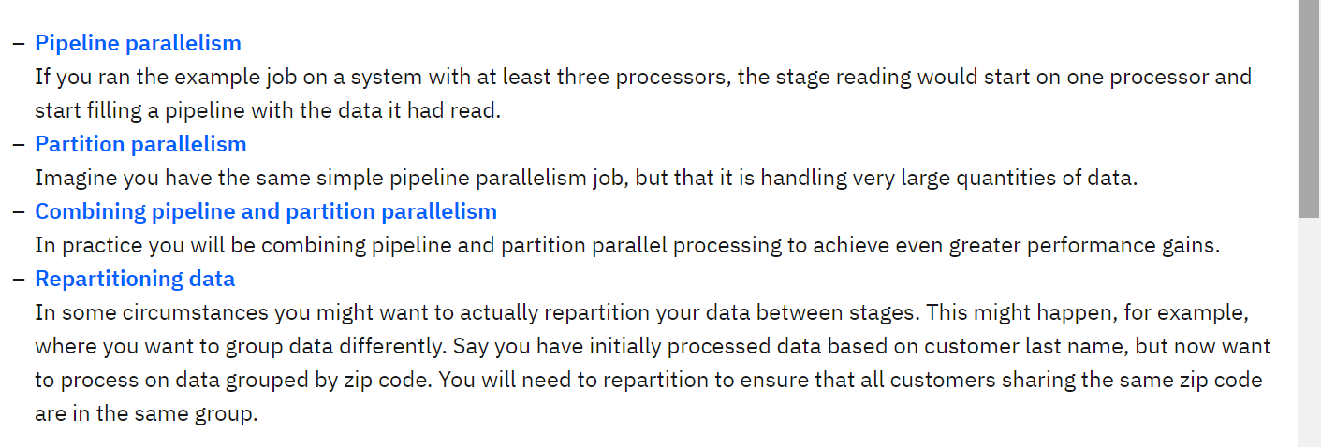

**Processing Stage**

Change capture:capture the changes

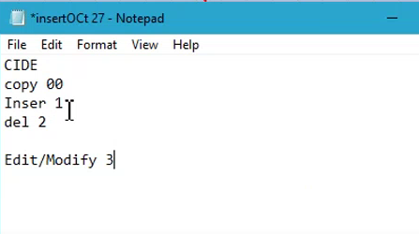

Change apply is for applying changes

Checksum : Use the Checksum stage to generate a checksum value from the specified columns in a row and add the checksum to the row. You can use the checksum value to check the validity of each row when it is written to the data target.

Filter is to filter the data based on condition

FTP: File transfer protocol from one 4server to another

Funnel : The Funnel stage copies multiple input data sets to a single output data set. You can use this operation for combining separate data sets into a single large data set. The Funnel stage is a processing stage. It can have any number of input links and a single output link.

Use the Lookup stage when:

* Having a small reference dataset.
* Doing a range lookup.
* Validating a row (If there is no corresponding entry in a lookup table to the key’s values, you can output the row in the reject link). [**data stage online course**](https://onlineitguru.com/datastage-online-training-placement.html) helps you to learn more skills and techniques from industrial experts.

Use the Join stage when:

* Joining large tables (you will run out of RAM with the Lookup stage).
* Doing outer joins (left, right, full outer).
* Joining multiple tables with the same keys.

Use the Merge stage when:

* Multiple update and reject links are needed (e.g. Combining a master data set with one or more update datasets)

A Slowly Changing Dimension (SCD) is a dimension that stores and manages both current and historical data over time in a data warehouse. It is considered and implemented as one of the most critical ETL tasks in tracking the history of dimension records.

What is Type 1 2 and 3 SCD?

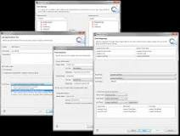

Type 1 – This model involves overwriting the old current value with the new current value. No history is maintained. Type 2 – The current and the historical records are kept and maintained in the same file or table. Type 3 – The current data and historical data are kept in the same record.

**Transformer stage**

The Transformer stage is used within a DataStage job (referred to as DS for the remainder of this article) to filter, transform, or re-direct data. Overall, you can define conditions in the Transformer that will affect the output. In this article, we will explore some of the ways that you can use the Transformer.

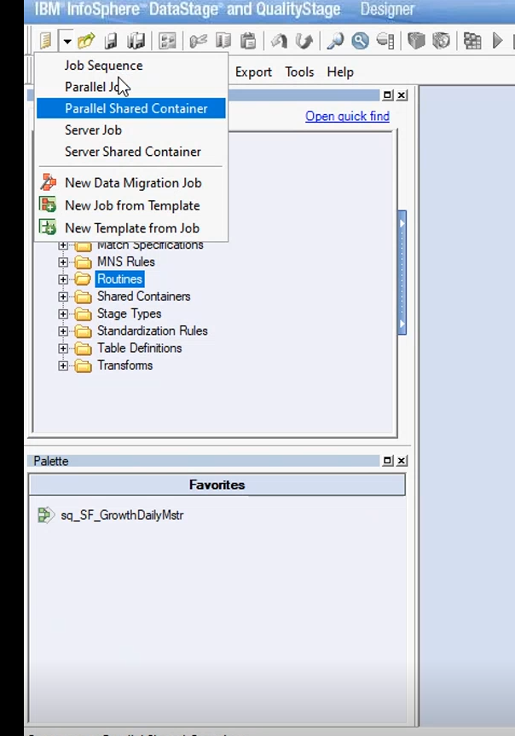

Parallel job is where ETL is performed

Parallel shared container is : the steps which u r doing repeatedly will be kept in container so that whenever is needed we can call that

Stages:

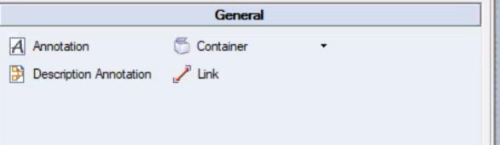

Annotation is used for writing a note

Link : Its used for linking purpose

Container:

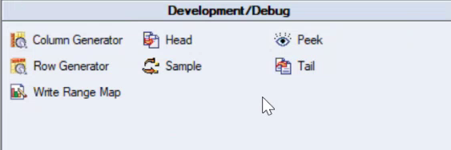

Debug section : Its used for debugging the jobs

**BASICS:**

Aggregator :

Transformer, copy stage

Runtime column propagtion